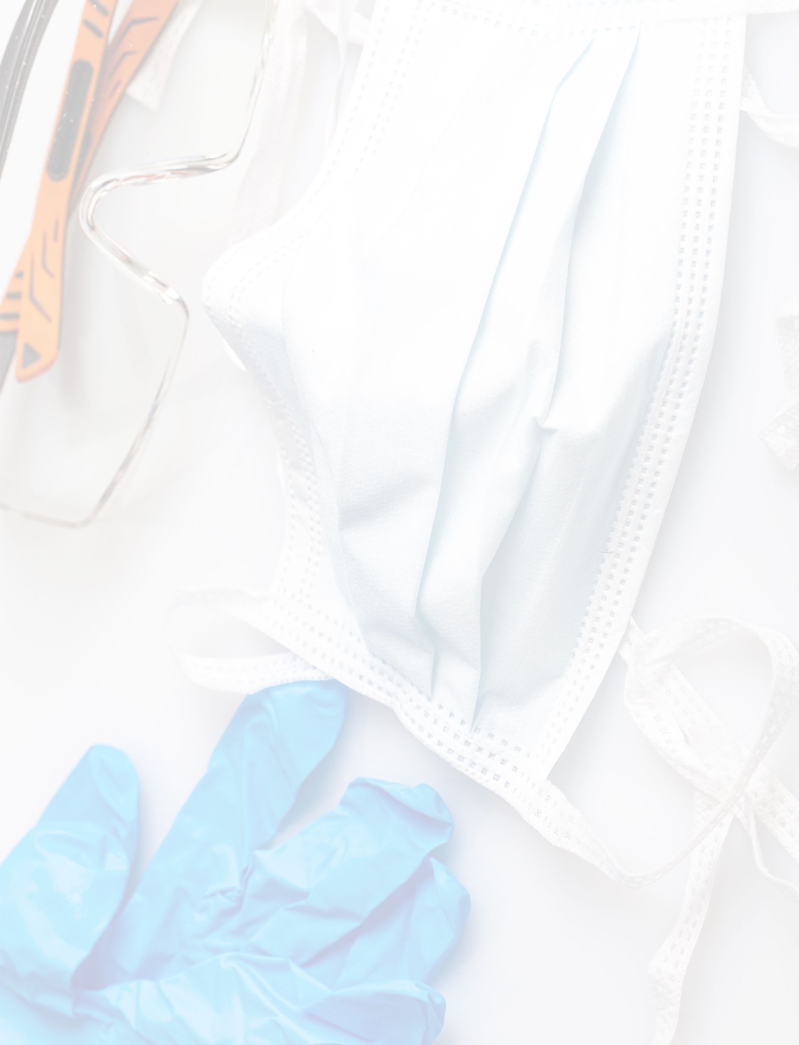
STAFF/EMPLOYEE FAQ

FAQ: Covid-19 and Personal Protective Equipment
{INSERT SPA NAME}
This document is intended to provide guidance on the proper use, sanitation and disposal of personal protective equipment (PPE). The study of COVID-19 is ongoing, and these guidelines are subject to change. Always follow the local, state or national regulations that govern the operation of your spa.
QUESTION | ANSWER
What are the symptoms of COVID-19? | COVID-19 can cause a wide range of symptoms ranging from mild to severe in nature. However, some people infected with COVID-19 do not experience symptoms.  People with the following symptoms or combinations of symptoms may have COVID-19:  - Cough  - Shortness of breath or difficulty breathing  Additionally, people with at least two of the following symptoms may have COVID-19:  - Fever - Headache  - Chills - Sore throat  - Repeated shaking with chills - New loss of taste or smell  - Muscle pain
How is COVID-19 spread? | The virus is spread mainly from person to person between people in close contact with one another (within about six feet). When an infected person coughs, sneezes or talks, they produce respiratory droplets that can be inhaled into the lungs of others.
I don’t feel sick and have had no symptoms associated with COVID-19. Should I wear PPE? | Yes. Some recent studies suggest that COVID-19 may be spread by people who are not showing symptoms. Wearing PPE such as cloth face coverings is intended to protect others if you are sick. Because not everyone infected with COVID-19 feels sick or exhibits symptoms, wearing a cloth face covering helps reduce transmission.  Because the novel coronavirus can live on some surfaces for extended periods and some disinfectants can irritate eyes and skin, wearing PPE while sanitizing areas of your spa is recommended.
What are the steps everyone should take to prevent the spread of COVID-19? | There are several precautions everyone should take to prevent exposure to COVID-19 and reduce its spread:  - Avoid close contact with people who are sick, especially if you are at higher risk for severe illness  - Put distance between yourself and other people (social distancing)  - Wash your hands often with soap and water for at least 30 seconds, especially after visiting a public place or after blowing your nose, coughing or sneezing. Click here to view the CDC’s video resource “What You Need to Know About Handwashing.” This page offers further guidance.  - If soap and water are not readily available, use a hand sanitizer that contains at least 60 percent alcohol  - Cover your mouth and nose with a cloth face covering when around others  - Wear a cloth face cover in public (cloth face coverings should NOT be placed on anyone who has trouble breathing or is unable to remove the mask without assistance)  - Do NOT use a facemask meant for a healthcare worker (N95, surgical masks)  - A cloth face covering is meant to protect other people in case you are infected  - A mask is not a substitute for social distancing  - Cover coughs and sneezes  - Always cover your mouth and nose with the inside of your elbow or a tissue, especially if not wearing a cloth face covering  - Throw used tissues in the trash  - Immediately wash your hands with soap and water for at least 30 seconds. If soap and water are not readily available, use a hand sanitizer that contains at least 60 percent alcohol  - Clean AND disinfect frequently touched surfaces daily, including tables, chairs, door handles, light switches, countertops, desks, phones, keyboards, toilets, faucets and sinks. This page offers guidance on the distinction between cleaning, disinfecting, and sanitizing.
Why does the CDC recommend cloth face coverings instead of medical grade facemasks? | Surgical masks and N95 respirators are in short supply and should be reserved for healthcare workers or other first responders who may come into frequent contact with those infected with COVID-19.
What can I use to clean and disinfect surfaces in the spa to prevent the spread of COVID-19? | Prior to disinfection, clean dirty surfaces with detergent or soap and water. This page lists EPA-registered disinfectants. Always follow the regulations governing your spa’s sanitation practices and materials.
Which types of personal protective equipment (PPE) are most useful for spa staff? | The types of personal protective equipment used by spa staff may differ based on the guidelines and regulations in place in your city, state, region or country. Always follow the laws and regulations under which your spa operates. The list below is comprised of PPE that may be most useful for spa staff  - Cloth face coverings (facemasks); do NOT use a facemask meant for a healthcare worker (N95, surgical masks, etc.)  - Disposable gloves (for sanitation purposes AND during treatments if mandated by law, spa policy or guest request)  - Disposable gowns (for sanitation purposes)  - Protective eyewear (for sanitation purposes)

Is there a proper method for putting on (donning) PPE? | Yes, the CDC recommends a specific sequence for donning PPE. When putting on PPE, follow this sequence AND adhere to the steps recommended below. You can find a video illustration of this method here.  - Gown  - Fully cover torso from neck to knees, arms to end of wrists and wrap around the back  - Fasten at back of neck and waist  - Mask  - Secure ties or elastic bands at the middle of your head and at your neck or around your ears  - Fit snug to face and below chin, allowing for breathing without restriction  - Goggles or Face Shield  - Place over eyes or face and adjust to fit  - Gloves  - Extend to wrist
Is there a proper method for taking off (doffing) PPE? | Yes, the CDC recommends a specific sequence for doffing PPE. When taking off PPE, follow this sequence AND adhere to the steps recommended below. You can find a video illustration of this process here.  Always treat the outside of worn PPE as though it is contaminated. If your hands become contaminated while removing gloves, immediately wash your hands for 30 seconds with soap and water or use a hand sanitizer with at least [XX%] alcohol  - Gloves  - Using a gloved hand, grasp the palm are of your other gloved hand and peel off first glove  - Hold removed glove in gloved hand  - Slide fingers of ungloved hand under remaining glove at wrist and peel off second glove OVER the first glove  - Dispose of gloves in a waste container  - Goggles or Face Shield  - Remove goggles or face shield from the back by lifting the earpieces or head band  - If the item is reusable, place in a designated receptacle for sanitation. Otherwise, dispose of item in a waste container  - Gown  - Unfasten gown ties, taking care that sleeves don’t contact your body when reaching for ties  - Pull gown away from neck and shoulders, touching inside of gown only  - Turn gown inside out  - Fold or role into a bundle and dispose of gown in a waste container  - Facemask  - Grasp bottom ties or elastic of the mask, then those at the top, and remove without touching the front  - If mask is reusable, place in a designated receptacle for sanitation. Otherwise, dispose of item in a waste container  - Wash hands  - Immediately after removing PPE, wash your hands for 30 seconds with soap and water or use a hand sanitizer with at least [XX%] alcohol
What protocols should I follow while wearing PPE? | The CDC recommends the following steps be taken to limit the spread of contamination while wearing PPE:  - Keep your hands away from your face  - Limit the number of surfaces you touch  - Change gloves if they tear or become heavily contaminated  Practice hand hygiene
How do I care for cloth face coverings (facemasks)? | Cloth face coverings should be routinely washed, depending on the frequency of use. A washing machine should suffice in properly washing a face covering. Cloth face coverings should be able to be laundered and machine dried without damage or change to shape.  Be careful not to touch your eyes, nose or mouth when removing your face covering, and wash your hands immediately after removing.

